**User Analysis:**

|  |  |  |
| --- | --- | --- |
| **General characteristics of users** | | |
| **Question** | **Answer** | **Implications** |
| What is their age? | 65+ | More methodical than other age ranges of users. |
| What is their gender? | Male and female, in equal proportions | Do not provide any imagery that suggests favoring of one gender over the other |
| What culture do they come from? | Can be any culture; communicating users are likely to come from different ones | Cannot assume users have same associations between physical and abstract ideas. Review interface choices and tools (i.e., use of buttons, arrows, direction of sentence structure) to ensure the principles used are universal human ones, not Western cultural ones |
| What physical abilities/disabilities do they have? | More likely to have disabilities: Poor hearing, vision, use of hands, reaction time, memory | Must adequately provide support for users with any of these disabilities: large, clear text, labelled icons and buttons, distinct color contrast between background and interactive features, minimal use of sounds or required scrolling, multisensory feedback |
| What is their background education? | Varied levels/types of education | Cannot assume user knowledge in many areas, so ensure the sentences can be followed without background knowledge |
| How much computer experience do they have? | In general, below average experience | Need to make system more beginner-friendly. Do not rely upon conventional interface objects (scroll buttons, menus, OS dialogue boxes) that first-time users may have never seen and cannot understand |
| **Psychological Characteristics** | | |
| **Question** | **Answer** | **Implications** |
| What is their cognitive style? | Potentially all classifications | Should make an easily-learned interface for all types of mental structures; do not favor one over others |
| What is their attitudes? Likes/dislikes? | Uncomfortable trying new things; blame themselves for errors | Interface should be inviting and have easy error recovery. Absolutely do not change the interface’s menu arrangements or steps to completing a task during a user’s session (to maintain locus of control) |
| What is their motivation? | Goal: trying to communicate | Users may be more willing to try and learn interface because communication is a vital important activity |
| **Knowledge and experience** | | |
| **Question** | **Answer** | **Implications** |
| What is the typing skill of users? | Varied skill levels should be expected | Cannot rely upon high-speed inputs. Do not require the user to type multi-key commands to perform tasks |
| How much system experience should they have? | Assumed that they do not have much experience | Need to be beginner-friendly (see “How much computer experience do they have?” above) |
| How much task experience should they have? | They likely have little experience with the task | Need to be beginner-friendly (see “How much computer experience do they have?” above) |
| How much application experience should they have? | They likely have little experience with the application | Need to be beginner-friendly (see “How much computer experience do they have?” above) |
| What is their native language? | Any generally-used native language | Need to make implementation work without relying on linguistic peculiarities of any given language |
| How much experience with other systems do they have? | Assumed that they do not have much experience with other systems | Cannot rely on previous connections made in other systems. Cannot assume knowledge gained from other applications |
| What is their level of computer literacy? | Computer literacy is most likely low | Need to make UI simple and intuitive enough for beginners, relying on metaphors to convey meaning |
| **Physical Characteristics** | | |
| **Question** | **Answer** | **Implications** |
| What handedness will the user have? | Could be either right- or left- handed | Will need to ensure that the system works well for both handedness |
| Will the users have color confusion problems? | The ratio between people with color confusion and without should be standard | Should be designing with possible color confusions in mind. It shouldn't be first priority, but making sure that the design works for people with color confusion would be good. |

**Task Analysis:**

Main Task: Communication between two users

Sub Tasks: Sending sentences, Adding/Removing images, connecting images, Creating/Deleting Sentences

|  |  |  |
| --- | --- | --- |
| **Task Object** | **Attributes** | **Actions** |
| Conversation | “Sentences” which make up the conversation  Members | Create New  Disconnect |
| “Sentence” | “Pictorial words” which make up the sentence  Sender | Create New  Edit  Delete  Send  Receive |
| “Pictorial Word” | Image/icon  Classification (i.e. part of speech) | Select  Add/Remove to/from sentence  Connect with other pictorial words |

|  |  |  |
| --- | --- | --- |
| **Question** | **Answer** | **Implication** |
| How frequent is the Main task? | Infrequent | Dedicate screen space and guidance to other sub-tasks |
| Which sub-tasks are most frequent? | Adding/Removing images, Connecting images, Creating/Deleting sentences, sending sentences (in descending order of frequency) | Dedicate more screen space and guidance to the most frequent sub-tasks. The most frequent sub-tasks need to be readily accessible |
| What training does the user have in the tasks? | Very basic training in their language | Cannot assume much understanding of the system |
| How important is the task to the user? | Non-Vital | Errors and delays are not disastrous |
| Who are the actors? | The two users |  |
| How are the task objects grouped? | The pictorial words are grouped by broad categories | Need to select useful, recognizable categories; utilize Gestalt grouping and white space to clearly partition categories |
| What are the information sources for the task objects? | The word images are found from online image sources | Must have clearly defined sources for images; avoid cultural issues with international image hosting |
| What is the result of the main task? | The two users communicate |  |
| How does the system communicate with the user? | The system must not use textual language to communicate | System must use alternative (image-based) methods to communicate with the users |
| What likely errors will the system have? | Misinterpretations, Incorrect connections, Incorrect Selections | Must be easy to undo moves and understand how to use the system |
| What is the system terminology? | Conversations are groups of sentences; Sentences are groups of pictorial words; Pictorial words are image representations of an expression | The interface should follow the metaphor of communicating through pictorial “building blocks” of words to make the task clear and intuitive for users |
| What are the relationships between tasks? | Images must be added to a sentence to be connected; A sentence must be created before you can add images to it | There must be easy transitions between adding and connecting images (which will happen most frequently and usually sequentially) |

**Interaction Design:**

As a universal, culture-independent method of building a sentence was a critical component of this assignment, all decisions made in regard to how the user interacts with the system to build the sentence were carefully chosen to support equal understanding among all users. The main drag-and-drop transfer of icons from the icon bin onto the canvas was designed as a metaphor for assembling a collage, and any user could reasonably be expected to understand this intuitive dragging process by identifying it with the real-life activity it represents. This also extends to the method of deleting individual icons, which requires the user to drag icons back into the bin to remove them from the canvas. While these actions will require a demonstration beforehand for users to understand what type of interaction has been implemented, they will have little to no difficulties in recalling and carrying out this quick, natural process after learning it once; this is the main reason the drag-and-drop design was used over other less intuitive possible design choices, such as nested pie menus generated from a single click on the canvas.

Connecting icons (with dashed lines for modifying adjectives and arrows for verbs or other connectors) is performed automatically when the modifying icon is dragged onto the object it modifies, producing the suitable connector and snapping the icon to an appropriate nearby location. This process is automated to standardize the appearance of sentences and ensure that users cannot create their own conventions for connecting sentences: as there is only one way to connect an adjective and its object, for instance, every user will produce identical sentences for the same icons, rather than some having arrows (pointing in either direction between icons) or the modifying icon being placed randomly on the screen. This generates universality in the final appearance of sentences, and all users will understand the sentence conventions in this interface after watching the instructional video and building a sentence for themselves.

**Screen Design:**

As the intended users are elderly, accounting for visual disabilities is a major concern in ensuring that the program functions as expected. Following this requirement, the canvas used for placing icons and building a sentence is made as large as possible, providing a clear view of what the user has written so far as feedback. The canvas occupying more than two-thirds of the screen is also conducive to using large and clear icons (described further below), allowing these icons to be sufficiently large for viewing without causing crowding or adding confusion when the sentence is quite long and intricate. Similarly, the icon bin is made large enough to effectively hold rows of up to four icons each, though the unit sizes of icons (described below) allow for varying numbers of row icons while maintaining consistency in arrangement. The user can easily view icons from within the bin to decide whether or not to drag them onto the canvas, and the immediate proximity of the Category Selector and the bin’s scrollbar allow the user to readily move through icon selections in a quick, yet logical fashion

The menus, both the top command bar and the icon bin sidebar, are designed to be as clear and accessible as possible without distracting the user or occupying too much of the screen. In order to minimize the appearance of these menus while building on the canvas, two edges of the screen are used to hold the toolbars rather than simply placing one on top of the other on the top of the screen. Beyond the apparent space-saving effect that maximizes screen space for the canvas and icon bin, this notably separates and partitions the system commands (Back to Chat, Send, Delete, etc.) from the Icon Category Selector buttons, ensuring that users will not confuse the two toolbars and their functions, such as assuming certain category buttons correspond to menu functions (i.e., “People” to “Add contacts”). The menu items are made as large as possible while still remaining inconspicuous during canvas usage, with their associated icons occupying maximum space within each border, to ensure that users will easily view and understand what each button does before pressing it. Lastly, the usage of buttons on toolbars for activating menu commands or switching between categories was chosen in order to make the selection choices as large, clear, and accessible as possible; other types of menus like dropdown or pulldown were considered, but ultimately passed over in favor of toolbars due to their consistent display of all possible choices and customizable button size design, along with appearing more intuitive to users with little experience with computers.

**Icon Design:**

In drawing icons to build the user’s sentence and convey meaning, simplicity and clarity were the key points for evaluating the designs. First and foremost, icons are designed to be large in order to account for poor vision among users, with every icon having a minimum size of 100x100 pixels. However, icons are not constrained by this size, and longer/taller icons have widths/heights consisting of larger multiples of 100 pixels. This variable width of icons is used to provide clear images of all types of objects or concepts, with naturally elongated objects like buses not being forced to uncharacteristically inhabit a constraining square. This choice was made over the use of fixed-size icons, which would require either the scaling-down or skewing of elongated objects until they fit the size, at which point they may be too unclear to interpret. Furthermore, the usage of multiples of 100 in icon dimensions allows the icons to still remain neatly arranged in the icon bin even when they have different sizes by establishing 100 pixels as a unit size for icons. The bin, designed to hold four units of width, can therefore display the largest icons such as “last” in-line with smaller ones without sacrificing any space, allowing for a neat and consistent design that evenly groups together all icons in each category.

For the actual design of icons, conveying a clear and unambiguous meaning with as few intricacies as possible was the primary goal when designing the images. Each icon involved with the creation of the sample sentence is designed to correspond to a single noun, verb, or adjective (allowing all connections and modifiers to be represented with the automatic dashed lines and arrows), and every design was evaluated first for its cultural universality before all else. As the icons are made for a public chat system between elderly users, general knowledge and immediate familiarity with the represented concepts trumped factual accuracy; for this reason, icons such as London and Hong Kong used iconic and familiar landmarks such as Big Ben and the Tian Tan Buddha rather than their flags, which many users were unable to identify. Abstract concepts, such as “year”, “past”, or “sister” were designed as diagrammatic, primarily to free these ideas from any cultural biases that would inhabit similar designs made for Western audiences (i.e., “past” utilizes the progression of technology and a reversed arrow, rather than the original idea of simply using a timeline with a backwards-facing arrow). Using these conventions, the icons will ideally be distinguishable and understandable (albeit with some thought requirements for the more intricate icons) for all users involved, rather than relying on Western concepts to design icons immediately recognizable for American users but confusing or unfamiliar with other nationalities. This will provide the greatest opportunity for the user to find, recognize, place, and read the exact words they are searching for, streamlining and enabling conversations between those of various cultures.

**Metrics:**

**Layout uniformity metric:**

Where Nc is the total number of visual components on screen, dialogue box, or other interface component. Nh, Nw, Nt, Nl, Nb, and Nr are, respectively, the number of different heights, widths, top-edge alignments, left-edge alignments, bottom-edge alignments, and right-edge alignments of visual components.

For our layout, displayed here:

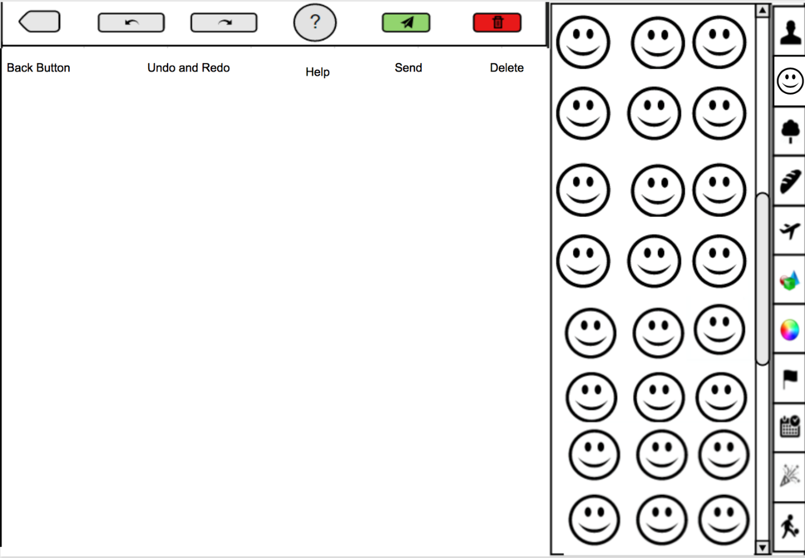

The values for the equation are as follows:

* Nh = 6
* Nw = 6
* Nt = 11
* Nl = 22
* Nb = 5
* Nr = 20
* Ncomponents = 42

Therefore, the M value can be calculated as:

And the Layout Uniformity can be calculated as:

For the **Task Visibility**, there are a total of five distinct user tasks that will be analyzed:

1. Sending sentence
2. Deleting sentence
3. Adding single icon or adjective
4. Deleting single icon or adjective

For each of these tasks, the visibility metric is determined through the equation:

Where Stotal is the total number of enacted steps to complete a use case and Vi is the feature visibility (from 0 to 1) of each enacted step i.

Sending sentence:

|  |  |  |
| --- | --- | --- |
| Enacted Step | Type | Visibility |
| Press and hold the send button | Direct | 1 |
| TV = 100% |  | Total: 1 |

Deleting sentence:

|  |  |  |
| --- | --- | --- |
| Enacted Step | Type | Visibility |
| Press and hold the delete button | Direct | 1 |
| TV = 100% |  | Total: 1 |

Adding icon or adjective:

|  |  |  |
| --- | --- | --- |
| Enacted Step | Type | Visibility |
| Select necessary category | Suspending | 0.5 |
| Scroll to the wanted icon | Exposing | 0.5 |
| Select and drag icon from icon bin onto board | Hidden | 0 |
|  |  | Total: 2 |

Deleting icon or adjective:

|  |  |  |
| --- | --- | --- |
| Enacted Step | Type | Visibility |
| Drag icon from sentence into icon bin | Hidden | 0 |
| TV = 0% |  | Total: 0 |

Total TV for all actions:

|  |  |  |  |
| --- | --- | --- | --- |
| Task | Number of steps | Total step visibility | Visibility associated with task |
| Sending sentence | 1 | 1 | 100% |
| Deleting Sentence | 1 | 1 | 100% |
| Adding icon or adjective | 3 | 2 | 66.66% |
| Deleting icon or adjective | 1 | 0 | 0% |

**Storyboards:**

Adding new object:

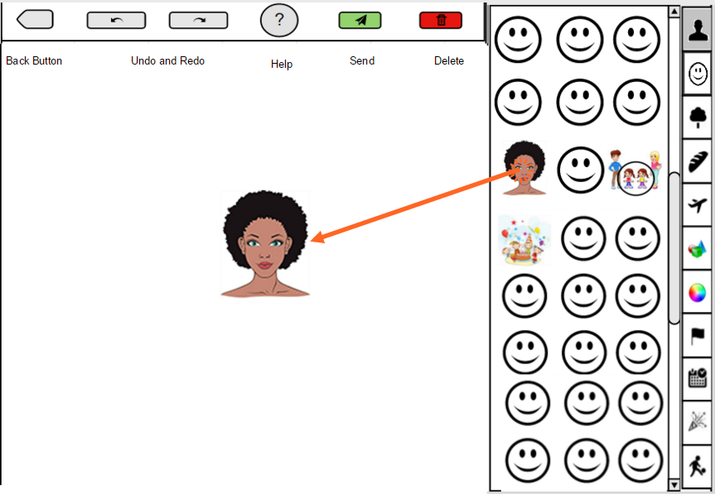

Object added:

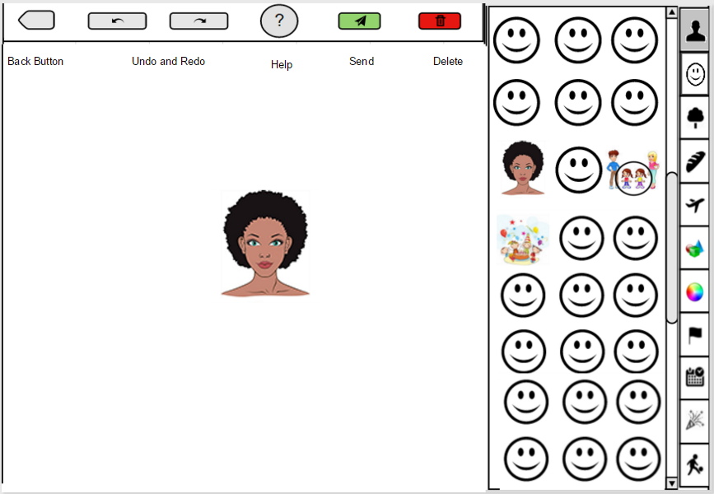

Adding new modifier:

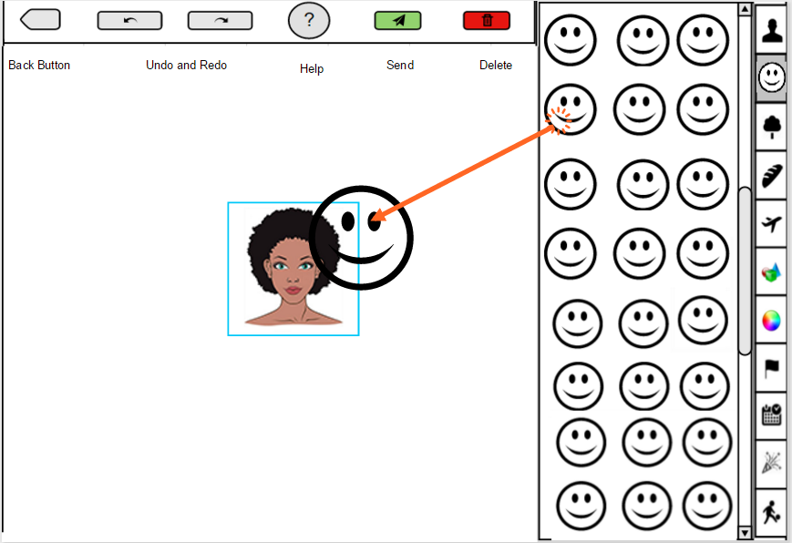

Modifier added:

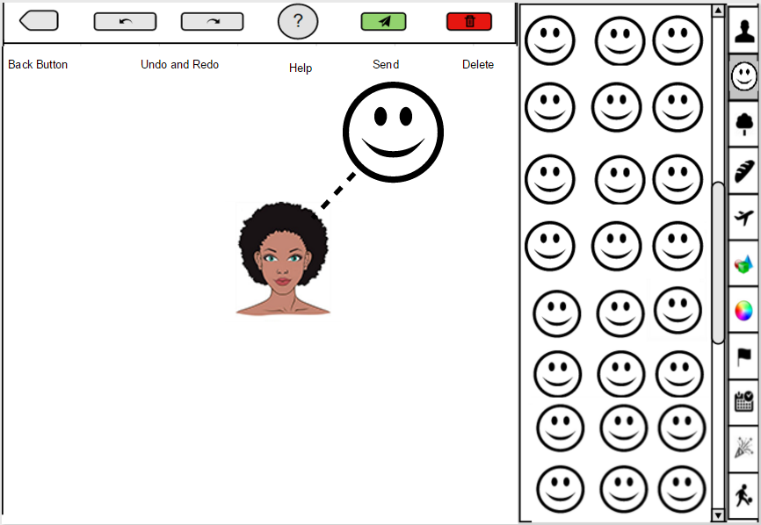

Adding connected object:

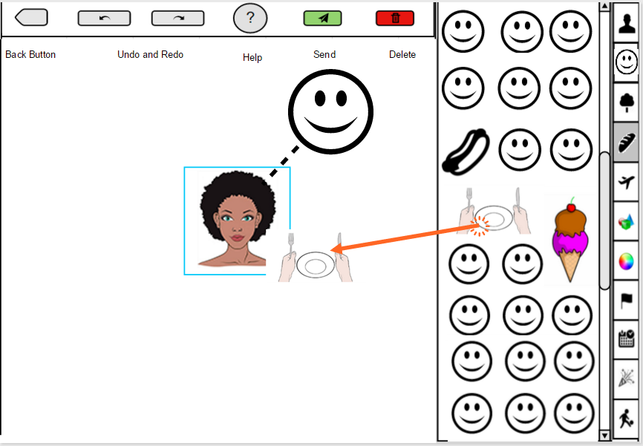

Connected object added:

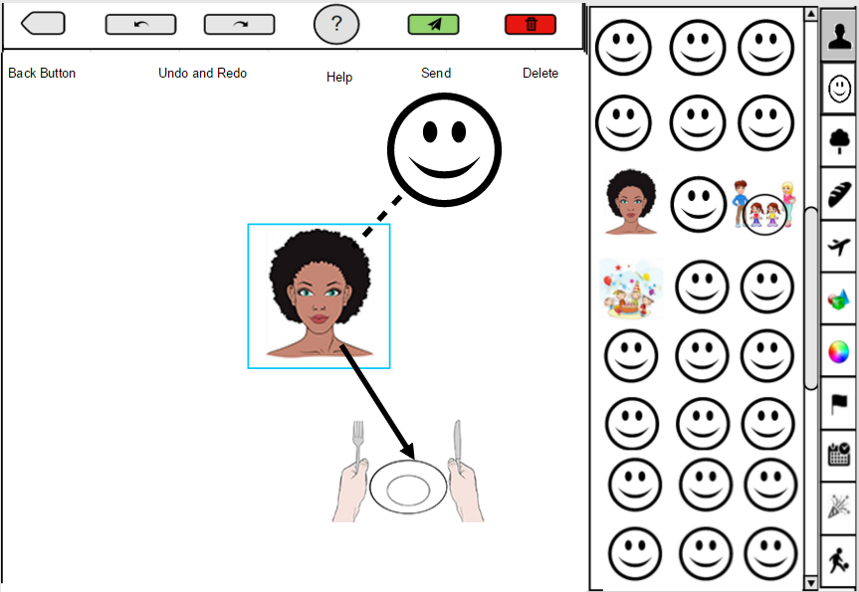

Dragging to remove object:

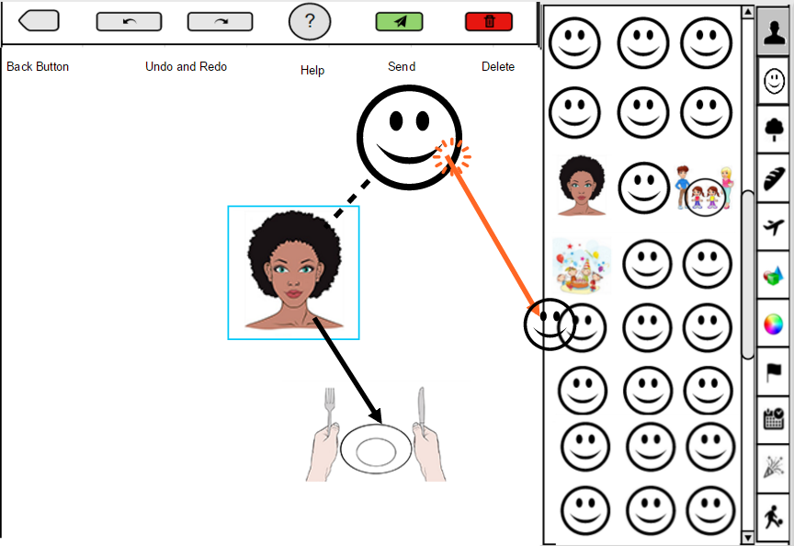

Object removed:

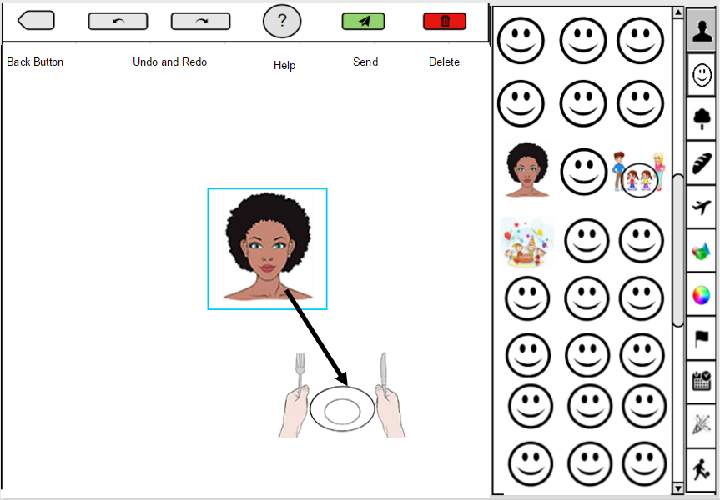

Deleting message:

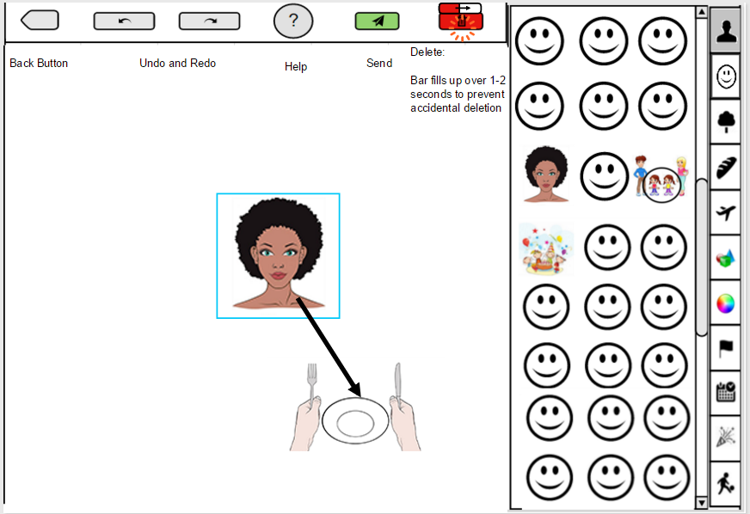

Sending message:

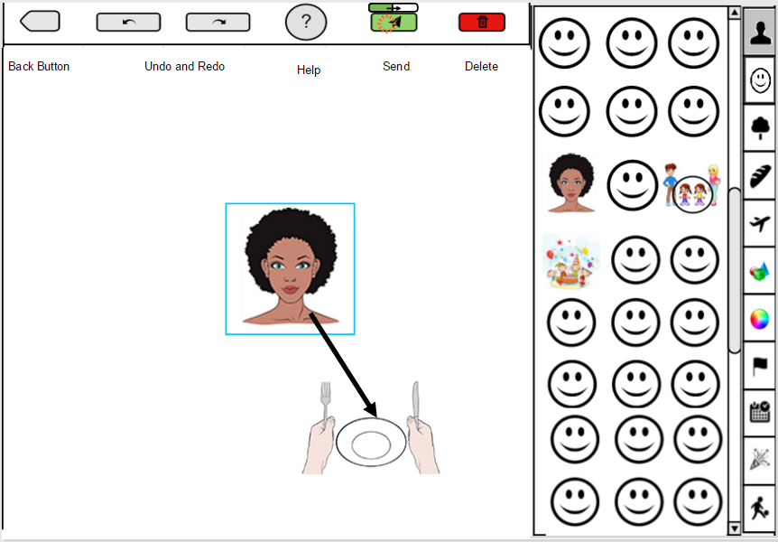

Full sentence:

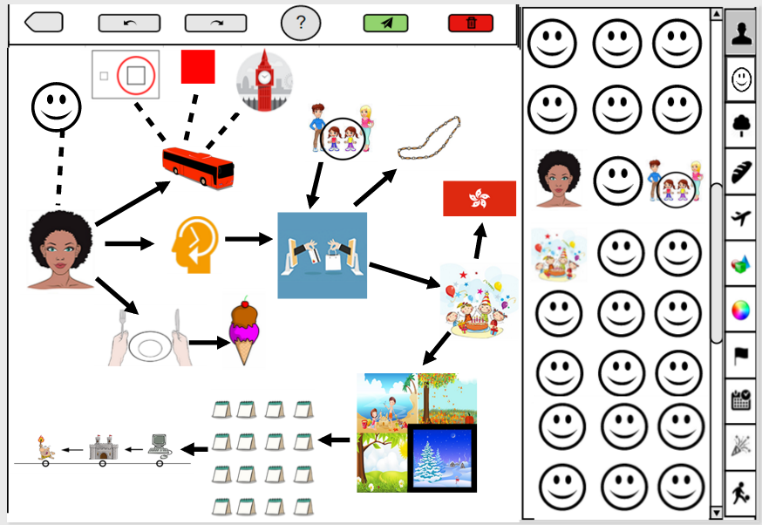

**User Study Results:**

|  |  |
| --- | --- |
| **Menu Icon** | **Fraction of Correct Identifications** |
| Back | 5/6 |
| Undo/Redo | 2/6 |
| Help | 6/6 |
| Send | 4/6 |
| Delete | 6/6 |
| People | 0/6 |
| Emotions | 6/6 |
| Nature/Plants | 6/6 |
| Food/Drink | 6/6 |
| Transportation | 6/6 |
| Objects | 0/6 |
| Colors | 6/6 |
| Flags/Locations | 3/6 |
| Time/Date | 4/6 |
| Events | 3/6 |
| Actions | 5/6 |
| Big | 3/6 |
| Happy | 5/6 |
| Bus | 4/6 |
| Eat | 5/6 |
| Woman | 3/6 |
| Birthday Party | 5/6 |
| Necklace | 3/6 |
| London | 0/6 |
| Red | 5.6 |
| Year | 0/6 |
| Hong Kong | 0.6 |
| Ice Cream | 4/6 |
| Last | 3/6 |
| Year | 0/6 |
| Winter | 2/6 |
| Sister | 0/6 |

As a result of this experiment, the most problematic icons that clearly could not effectively convey their meaning (Year, Hong Kong, London, Sister) were revised in order to make their meanings more unambiguous and apparent. Other icons that potentially misled some users (Necklace) were also revised into the final versions used in the storyboards. The user study used to obtain these results, along with the consent form, is enclosed below.

Sources Used

Chisnell, Dana, and Janice Redish. "Designing Web Sites for Older Adults: Expert Review of Usability for Older Adults at 50 Web Sites." *AARP.org*. AARP, 1 Feb. 2005. Web.

Nielsen, Jakob. "Seniors as Web Users." *Nielsen Norman Group*. Nielsen Norman Group, 28 May 2013. Web. 11 Apr. 2016.

Robbins, Kay. “CS 6693: User interfaces and usability, Week 12: Metrics.” *UTSA.edu.* University of Texas, San Antonio, 17 Apr. 2006.